What is SDLC: Software Development life cycle

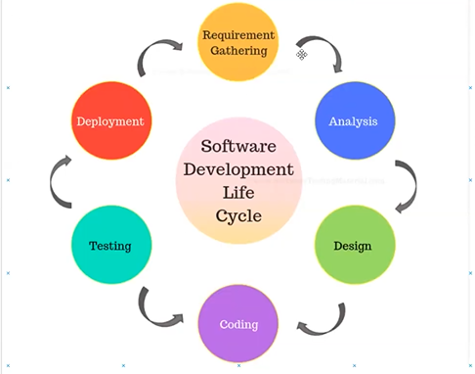

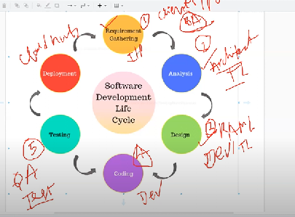

what is SDLC process: Software development lifecycle

what is waterfall & Agile process (99 % most of the company is using currently Agile Methodology process)

Water fall -- legacy process

V model

Spiral Model

Increment model

Agile Model-Trend

Water fall--> it is an one of the SDLC process

SRS -- Software Requirements Specification

BRD -- Business Requirements Developments

BA -- Business Analyst

HLD --High Level Design

LLD -- Low level design

FR --

NON- FR--

what is SRS/BRD

Agile Process: is nothing but an incremental model or spiral model

-------------------------------------

Requirements --- Product owner -(Clients), BA

Analysis -- Architect, Tech lead

Design -- Tech lead /Developers

Development -- Developers

Testing - QA/Testers

Deployment & Support(Operational)

what type of meetings? (All team members, PO, BA, Scrum master, Architect, dev, testers ...ets)

---------------------

1-Backlog grooming ---- weekly once -Requirements for product, Grrom the stories, user story points 1--5

2-Sprint planning --- 2 weeks once -- Dev/QA they need to pick /Assign the user stories (scrum master assign)

3-Daily scrum /Standup -- every day it will happen ( 15 mints) with in sprint -14 days)

what you have done yesterday, what you are doing to working today, any issue or blocker)

4-Sprint review/demo -- 2 weeks once - demo with PO and Team, will take suggestions

5-Retrospective -- www -

what went well

what went wrong

what we need to improve

fast delivery

2 or 3 sprints we are going to deploy our app into production

Regions

------

Dev

QA -test

Prod --live

sprint - 2 weeks

14-4 -- 10 working days

8 points - 1 story point = 6 hours 8\*6=48

